**Departament of Therapeutical Medicine**

**Alecsander Kistauri - Head of Department**

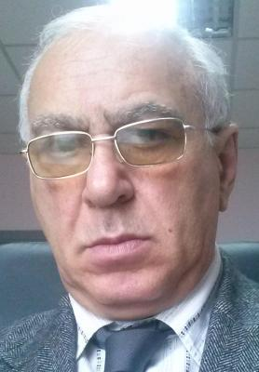

**Head of Department**

Date and place of birth: 10.11.1948, Tbilisi Education: Tbilisis State medical institute – 1966-1972 Specialty: Doctor Scientific quality: MD-1982; Phd – 1992 Scientific rank: Docent – 1984; Professor – 1994 Work experience: 1973-1981 Doctor-internist of Tbilisi Central Clinic of Railway; 1981-2017 – Tbilisi State medical university: 1981-1984 - assistant; 1984- 1993 – professor; 1993 – Head of department of internal medicine. Scientific interests: cardiology, diabetology, diabetic foot, osteology Scientific Works 150 Scientific Works; 3 Book; 2 invention; 1 Patent; Member of Georgian Scientific Academy of Medicine; Prezident of internal medicine association of Georgia Prezident of diabetic foot assotiation of Georgia Vice-Prezident of Atherosclerosis assotiation of Georgia Knowledge of foreign languages: English, German, Russian.

.

**Mamia Zodelava**

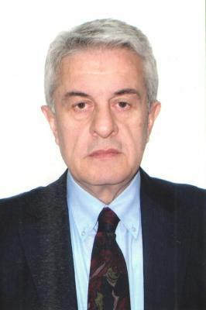

Date of birth: 2.03.1949 Education: 1966 - 1972 Tbilisi State Medical Institute 1972 - 1975 Tbilisi State Medical Institute Post graduate Scientific Quality: 1975 Candidate of Medicine Sciences 1987 Doctor of Medicine of Medicine work experience: 1976-1978 Tbilisi State Medical Institute Assistant to Proceedings Department 1978 - 1984 Institute of Physics of the Tbilisi DoctorsChair of Hematology and Transfusiology Assistant 1984 - 1988 Institute of Physical Education of the Tbilisi Doctors Doctor of Hematology and Transfusiology Chair 1988 - 2006 Institute of Physics of the Tbilisi Doctors Head of the Department of Hematology and Transfusiology, Professor 2001 - Director of the current resident program (Specialty Hematology), Directorate, Localhead 2001 - 2015 Hematology and Chemotherapy Clinic "Hema", Director 2006 - Present Full Professor of Oncohemology Department of TSMU Oncology and Hematology Department 01.05.2015 - Director of the "Hematology Center of M. Mazelava" Ltd till now Membership of the Dissertation Board: 1996 - 2000 Chairman of the Dissertation Board of Tbilisi State Medical University M14.29 2001 - 2004 Member of the Tbilisi State Medical University, Mrs. 14.05 Dissertation Board 2004 - 2006 Deputy Head of the Dissertation Board of Tbilisi State Medical University M.14.19.N11 2007 - 2009 Head of the Dissertation Board of the Faculty of Medicine of TSMU Membership of the Scientific Board: 1996 - 2005 State Medical Academy Member of the Great Council 2004 - 2005 State Medical Academy Chairperson of the Faculty Board 2007 - 2009 Member of the Academic Board of Tbilisi State Medical University Membership of Scientific Academy: 1997 - Presented as a member of Georgian-American Medicine and Surgery Academy 1998 - present until the Academy of Medicine of the Georgian Academy of Sciences True member Professional Association Membership: 2002 - present Member of the Georgian Heatologist Association Scientific Leadership: Head of the thesis performed for scientific degree of 18 academic doctors Scientific Publications: 103 Scientific Thesis, 1 monograph, 4 methodical recommendation / guideline, 1 author of the invention Participated in 9 clinical trials as the main researcher.The winner of the State Prize of the Year 2012 Language Knowledge: Georgian - Native Russian - fluent, English - perfect

**.**

**Dudana Gachetchiladze**

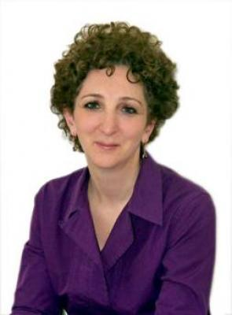

DATE PLACE OF BIRTH: January 11, 1965,Tbilisi, Georgia WORK EXPERIENCE -1996-1999 Post-graduate training in radiology -1996-1997 Residency program in radiology -1994-1996 Residency program in neurology -1992-1994 Internship, field Angiology EDUCATION -2005 Received the scientific degree of Doctor of Medical Sciences -1999 Received the scientific degree of Candidate of Medical Sciences -1987 Graduated from Tbilisi State Medical Institute with Diploma of Honours FIELD OF SPECIAL INTEREST: Vascular disease PUBLICATIONS: Up to 150 publications, Two monographies (Noninvasive diagnostics of cerebrovascular Diseases 2007y. Noninvasive diagnostics of exstracrainal vessel pathologies 2014y). . -. PRESENTATIONS: Intern. Congress of Georgian Radiology- 1995 2000, 2005, 2010, 2016. Stroke-1998, ECR-1999, 2001,2002, 2003, 2004, 2006, 2014 CIRSE -1997,1999,2001, RSNA 2004, 2007,2011 EFNS 2009, ECCR-2012. ACNR-2015 ADDITION INFORMATION: -2000-present Assistant lecturer of Georgian State Medical University -1997-present Member of the Georgian Association of Radiology. -1999-present Member of the International Union of Angiology -1999-present Member of the Georgian Association of Atherosclerosis 2005-present Deputy editor of Georgian Journal of Radiology 2013–present Member of ESR education commetee LANGUAGE SKILLS Georgian - native, English - fluent, Russian-fluent

**Alecsander Aladashvili**

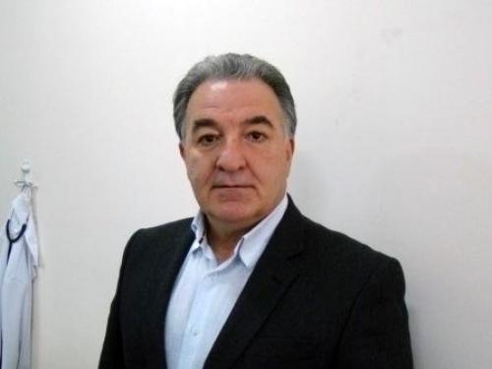

EDUCATION: Tbilisi State Medical Institute - 1968 - 1974; Diploma of MD; PROFESSIONAL TRAINING: 1995 - 1996 Internship, Tbilisi; II city hospital, 1978 - 1980 - Special Training (ordinatura) in the Department of Cardiology, Baculev Research Institute of Cardiovascular Surgery, Moscow; 1980 - 1983 - Special Training and Research (aspirantura), Department of Cardiology and Cath.Lab. Baculev Research Institute ofCardiovascular Surgery, Moscow; Diploma of ``Candidate of Medical Sciences``; 1985 - 1989 - Special Training and Research (Doktorantura), Department of Cardiology and Cath.Lab Baculev Research Institute of Cardiovascular Surgery, Moscow; Diploma of ``Doctor of Medical Sciences``; 1996 -2001 - Special Training (2 month/year) on “Interventional Cardiology”. Saarbrucken University Clinic, Germany. Bad Krozingen Heart Centre, Bad Krozingen, Germany. WORKING EXPERIENCE: 1976 -1978 – Internist, Telavi Regional Hospital, Georgia; 1983 -1985 - Assistant Professor - Chair of Internal Medicine, Tbilisi State Medical University; 1989 -1994 - Professor - Chair of Internal Medicine Tbilisi State Medical University; 1995 -1997 - Head of chair of Internal Medicine, Javakchishvili Tbilisi State University; 1997-until – Head of Department of Interventional Medicine, Chapidze Today Emergency Cardiology Centre. Tbilisi. 2012- until - Head of Department of Internal Medicine, Medical faculty, Today Javakchishvili Tbilisi State University. 2013 - until - President of Georgian Society of Cardiology 2005 - State Prize Laureate Scientific publications - > 50 1997 – First Coronary Angiography in Georgia 1998 – First Percutaneous Coronary Artery Stenting in Georgia

**David Tatishvili**

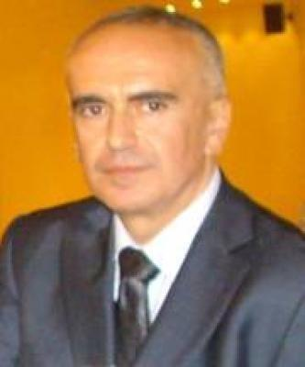

Born on 1962 in Tbilisi.He graduated Of the Segond School and Tbilisi State Medical Institute with honors.In the 1987 he graduate the post graduate degree in the same institut.he defended candidat dissertation in 1987 and doctoralthesis in the 1992.In 1994 he was elwctyed as Vice-Prezsdent of Georgian Association of Radiologysts.In 1994 David Tatishvili eas awarded with professor.In 1997 he was elected academician of the Georgian Academyof Sciences of Medicine.Duruing these years David Tatishvili worked ae e professor at the department of oncology at the TYbilisi State NMedical Institute.From 1968 to 1997 David Tatishvili was the head of Ultrasound Diagnostic Departments of the Georgoian Oncology Scientific Center. David tatishvili founded The Ultrasound Study-Reasersh Center(1997),David Tatishvili Medical Center in Tbilisi(2005) with philials was opened in Marneyli,Telavi,Senaciand Borjomi(2003-2005),multi-profile hospital clinics at the David Tatishvili Medical Center(2011) and David Tatishvili Sports Medicine and Rehabilitation Center(2013).He is the autor of Ultrasound Diagnostics Atlas, monographs and 110 scientific worcs.During these years David Tatishvili has Participiented in numerous scientific symposia and conferences in differant countries.In 2012 David Tatishvili was awarded with the Order of St.Nicolas.

**Karaman Fagava**

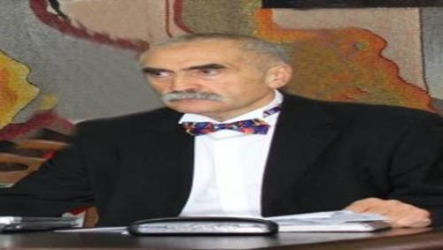

Personal information.Born in Tbilisi 6/V 1948. Languages:Georgian (native), Russian (fluent as a native), English (good), Germany (good), French (basic) Education, Scientific Degrees&Titles Matura - 1965, Tbilisi Secondary School # 77MD - 1971, Tbilisi State Medical Institute, Faculty of General MedicineInternship in Pediatrics - 1971-1972, Tbilisi #1 HospitalCandidate of Medical Sciences (Ph.D.) - 1975, Tbilisi State Medical InstituteDocent - 1984, Highest Attestation Commission of the USSRDoctor of Medical Sciences (Habilitation) -1990, Moscow Institute of Pediatrics, Academy of Medical Sciences of the USSRProfessor - 1992, State Committee of Education of the USSRAcupuncture-1978, Moscow Central Institute of Medical Postdiplomic EducationLaser Therapy -1980, Moscow Central Institute of Reflex therapy (Acupuncture) Pediatrics (for teachers of high medical schools) - 1987, Moscow # 2 Medical InstitutePulmonology 1994, Natters Hospital, Innsbruck, Tyrol, AustriaManagement of ARI & DD-1995, WHOs special courses in Tbilisi Pediatrics - 1996, University of Saarland, Homburg/Saar, Germany IMCI (Integrated Management of Childhood Illness) – 2001, Special courses in Tbilisi under the umbrella of UNICEF and WHOESPGHAN Summer school on Pediatric gastroenterology, hepatology and nutrition (Tbilisi, Georgia)–2005Summer school “Update Ernährungsmedizin und Pädiatrie” (Giessen, Germany) - 2007 ,Adolescent Medicine - Oxford University, UK - 2007 Summer school “Adolescent Medicine”-St. Petersburg, Russia - 2008 ,Seminar “Failure culture and human resource management in healthcare” (Frankfurt, Germany - 2010 ESPGHAN Summer school on Pediatric gastroenterology, hepatology and nutrition (Tbilisi, Georgia) – 2016 OccupationChildren hospitals and outpatient clinics in Rustavi,Gardabani and Tbilisi, Georgia 1971-1973–Pediatrician Tbilisi State Medical University 1974-1996 - Consequently senior laboratory assistant, assistant-Professor, associate Professor, Professor 1996-2006 - Head of the Chair of Pediatrics &Adolescent Medicine Since 2006-Full Professor,Child&Adolescent MedicineMinistry of Labor, Health & Social Affairs of Georgia1999-2004-Chief Pediatrician PublicationsAbout 600 publications, including 3 manuals and 5 monographs.Citation index 1260 (IV.2018), Hirsh index - 11 (IV.2018).Participation (as a presenter) in more than 40 international conferences.Organization (as a president / vice-president) of about 30 conferences, including 9 international ones. Guidance (Co-guidance) of Research ProjectsHealth and Health Related Behavior of Adolescents in Georgia (SCOPES- Switzerland).Bacteriophage Therapy in Pediatrics (STCU-International Consortium)Management of Rare Diseases (GNSF-Georgian National Science Foundation- Fond Rustaveli www.rustaveli.org.ge-Georgien) Antibiotics usage in Georgia (WHO) Guidance of 23 PhD students. Scientific BoardsMember of Editorial boards of scientific journals ”Georgian Medical News”,“Georgian Pediatrician”, “Modern Pediatrics” (Ukraine), “The Italian Journal for Adolescent Medicine”Health education (papers, booklets, broadcasting, telecasting)4. International cooperation: PRINTO (Pediatric Rheumatology International Trials Organization) - www.printo.it EuTEACH (European Training in Effective Adolescent Care and Health) - www.euteach.com EPIRARE (European Platform for Rare Disease Registries) - www.epirare.org ARPEC (Antibiotic Resistance and Prescrib fEducation of Georgia,for high academic achievements1971–Diploma with excellence (for high academic achievements),Tbilisi State Medical Institute 1981-Honor Diploma, Tbilisi State Medical Institute1998 - Certificate of The Best Lecturer, Tbilisi State Medical University1998-Order of Honor (of Georgia)2000 Award from the European Association on the Pediatric Education for the best presentation of the year 2003–Iliya Chavchavadze prize and medal from the Society for Science popularization “Zodna” (for the achievements in the field of Health Education)2016–Elected as a Member of the Georgian Academy of Medical Sciences

**Nodar Emuxvary**

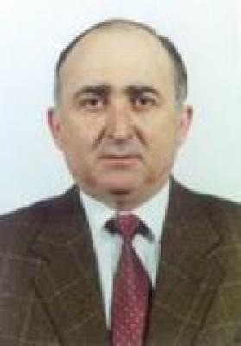

Doctor of Medicine, Professor, Academician of the Georgian Academy of Medical Sciences.He was born on June 2, 1943 in the village of Shechellet in Gali district. After graduating from Gali # 1 middle school{ 1959), in 1961 he was enrolled at the Faculty of Medicine of the Tbilisi State Medical Institute, after graduating (1967).he worked as a clinic in Akhaltsikhe District. In 1970 he entered the Tbilissi Syate Medical Institute post graduate faculty at the chair of Internal Therapy. After graduating, he was appointed as Assistant at the same Chair, then as a Dotsent,Professor and for 21 years head at the same Chair. 1975 Defend Candidate Thesis, while. 1993 Doctoral Dissertation.1994 He was a Dean of the Medical Faculty of Tbilisi State Medical University. Seens 1995 He was appointed as a Vice-Rector in Tbilisi State Medical University, where he worked till 2003. Also He workd to the head of the Department of Internal Diseases of the same University until 2014. After that he has been dismissed Georgia-Israeli private clinic "helsicor". which is successful clinic n cardiology, cardiosurgery and cardiovascular surgeon specialties in Georgia and South Caucasus. 1976-79. Worked at In Afghanistan, the chief doctor was awarded with the honorary diplomat of the Afghan Embassy.He is the Knight of the Order of Honor.He has been.Member of Tbilisi City Hall Advisory Board diuring 5 years.He is the author of 120 scientific works. His editorial published 2 volumes of manuals in internal medicine. He is a member of the editorial board of other medical journals. He was 5 years old of the head of the TSMU Dissertation Board. In Cardiology.Is a member of the editorial board of other medical journals. His guidance is maintained by 13 candidate and doctoral dissertation

**Giorgi Svanidze**

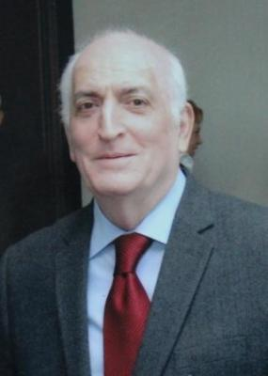

Born - 07.08.1948. Poti ,Georgia In 1965 -1972 studied at Tbilisi State Medical Institute, the Faculty of Medicine . 1972-1977 – worked as a surgeon of Poti and Khobi hospitals. 1977-1984 –worked as a Scientific Researcher of the Central Scientific Laboratory of Tbilisi State Medical University and in the Department of Surgery of the Second Clinical Hospital. 1984-1986 – worked as a doctor in Angola. 1986-1991 –Moscow Acad. A.V Vishnevski Institute of Surgery, in 1989 defended his candidate dissertation there. 1991- up today – works in the department of US Diagnostics of the Research Institute of Clinical Medicine. 1997 – defended PhD Degree 1996- was awarded the State Prizes in Science in the Field of Medicine with a group of authors (Head F. Todua) 1996-2006 –professor of the Department of Radiology at Tbilisi State University, Faculty of Medicine. 2006 –up today -a full professor of The Department of Medical Radiology at Tbilisi State Medical University. 2017 - academician of the Academy of Medical Science. He has published 109 scientific works in national and in foreign scientific journals; co-author of monographs: “Surgical Diseases of the Liver and Ultrasound Diagnostics of Biliary Tract”; “Ultrasound Changes of Parenchymal Organs in Visceral Leishmaniosis”; “Radiation Diagnosis and Treatment of Liver Abscess”. Participates in different International Congresses and Symposia in Radiology: Austria, Germany, Spain, USA, Russia, India and Nepal. He is a Member of Editorial Board of “Georgian Journal of Radiology “”. He is a member of the European and American Ultrasound Diagnostic Associations, European Society of Radiologists. 2006- one of the coauthors of Residential Program in Medical Radiology of Tbilisi Medical University: Program Director, Local Supervisor, author of license test-questionnarie. Co-chairman of certification Exam. Giorgi Svanidze has been awarded with Order of Honor.

**Revaz Tabukashvili**

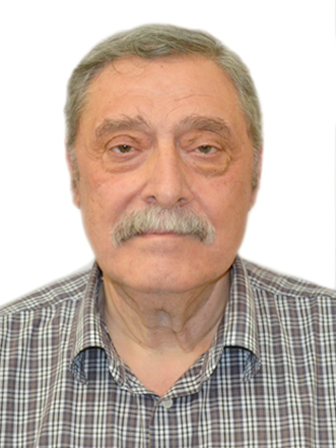

Revaz Iraklis dze Tabukashvili was born in 1949 in St. in the family of a servant in Tbilisi. After graduating with a gold medal in 1966, he enrolled in the medical faculty of the Tbilisi State Medical Institute. During his studies at the institute, from 1968 to 1971, he was the dismissed secretary of the Committee of the Communist Union of the Faculty of Medicine. In 1971-72, he was the chairman of the students' trade unions of the Medical Institute. During his studies, he was a nominal scholarship holder. After graduating from the institute with honors in 1972, he enrolled in postgraduate studies at the Department of Biochemistry, graduated in 1975. 1975-80 In 1980, he started working as an assistant at the Department of Diseases, from 1990 as a docent, from 1992 as a professor, and from 1994 as a head of the department, in 2006 as a professor of the direction of another professor of the former Department of Medicine No. 2. Since 2007, he has been the head of the Propedev Department. From 1980 to 1984, he was the retired secretary of the Part Bureau of the Faculty of Medicine, from 1984 to 1994, he was the deputy dean of the Faculty of Medicine. In 1980, he defended his candidate's thesis, the topic was performed in Tbilisi Medical Institute and in Moscow, military unit 64688 (Institute of Aerospace Medicine). In 1981, by order of the Ministry of Defense of the Soviet Union, a closed subject was carried out, which played a major role in determining the cause of death of deceased pilots. Since 1983, he was invited to military unit 64688 to do his doctoral thesis. In 1990, he defended his doctoral thesis in St. in Moscow. In 1991, the Academy of Sciences of the USSR published his monograph "The role of lysosomes in the mechanisms of resistance and adaptation", Problems of space biology, vol. 71. The mechanisms of radiation effects were studied by him, the protein was isolated and studied during the radiation irradiation of the protection mode. In 1994, he was awarded the title of professor. Since 1980, he has been a member of the Council of the Faculty of Medicine. In 1994-2006, he was a member of the Scientific Council of TSU. Since 1996, he has been a member of the Dissertation Council of the State Medical University. He is the author of 144 scientific works, 6 monographs, 2 textbooks, 5 lecture courses. He participated in the translation of a foreign book and is the editor of this guide. He participated in 31 international scientific conferences and 7 international scientific researches. Under his guidance, 6 dissertations were defended, among which one was completed in St. with the University of Toulouse. Currently, there is 1 thesis topic supervisor. Member of the board of the Georgian Society of Internists, member of the board of the Association of Physicians, member of the New York Academy of Sciences, member of the European Atherosclerosis Association, member of the United States of America Academy of Sciences, president. Participated in 20 medical methodology studies, continuous professional development and international courses and seminars. In 1998, together with the employees of the department, he founded "Therapeutic Clinic of the Patriarchate of Georgia for the Indigent and its Development Fund", which became the base of the Department of Disease Prognostics of Tbilisi Medical University and operated until the end of 2021. Since December 2021, he has established the "Palmedi" clinic, which is also the base of Tbilisi State Medical University.